**How to execute python code:**

python + code name

For example:

python CarRun.py

**Case1:**

If you are using the original system image of the Raspberry Pi, you need to install the GPIO library file based on the Raspberry Pi.

Method 1: You need to input: sudo apt-get install python-dev

(Note:This step must be networked)

Method2:

1. If you don't have a network, you need to transfer the RPi.GPIO-0.6.3.tar.gz file in the to the Raspberry Pi system by SSH Secure Shell Client.

This archive is included in file (6.Software and documentation)

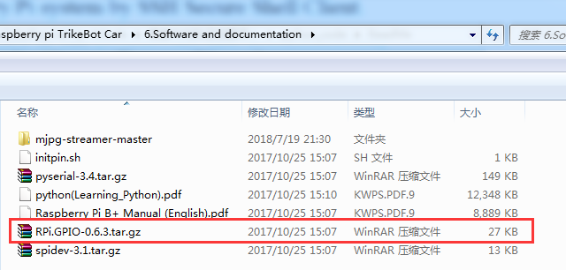

(2)Then, you need to input: tar -xvf RPi.GPIO-0.6.3.tar.gz

(3)You need to input：cd RPi.GPIO-0.6.3

(4) You need to input: sudo python setup.py install

After the above steps, we can successfully execute the code written in python.

**Case2:**

If you are using the robot car system image which we provided, you don't need to install the GPIO library file, just input the command to execute the code written in python.